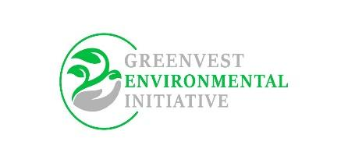

**NARRATIVE REPORT ON THE PARTNESHIP MEETING WITH THE FEDERAL DEPARTMENT OF FORESTRY, FEDERAL MINISTRY OF ENVIRONMENT, NIGERIA**

**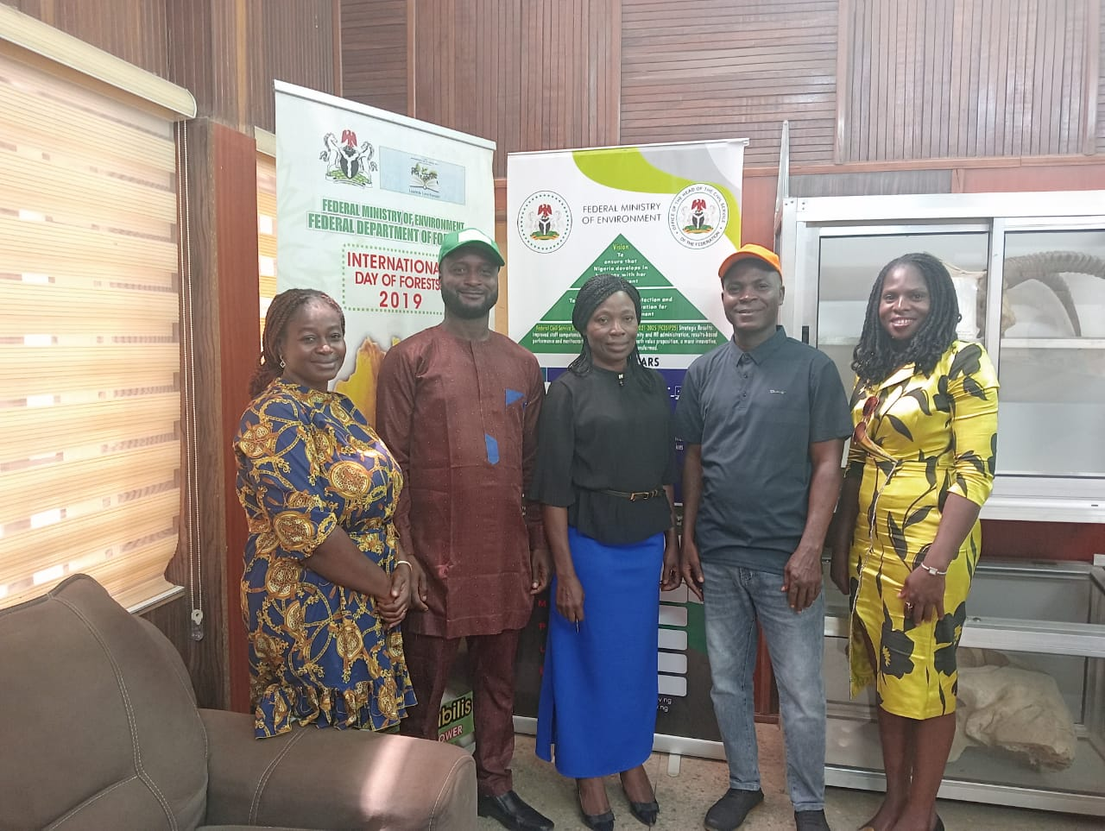**

|  |  |
| --- | --- |
| **Mission** | Green Vest Environmental Initiative Partnership Advocacy and Stakeholder Engagement |
| **Date** | 5th July 2023 |
| **Venue** | Conference Hall Department of Federal Ministry of Environment, Abuja |
| **Introduction**  On the 5th of July 2023, representatives of the Green Vest Environmental Initiative Partnership visited the Department of Forestry, Federal Ministry of Environment, to discuss various environmental initiatives, partnerships, and advocacy efforts. The purpose of the visit was to explore potential areas of collaboration and seek support from the department in advancing the goals of the Green Vest Environmental Initiative Partnership. The following individuals were present during the meeting: | |
| **Attendance** | |
| Mrs Nana Fatima Paturel Founder Greenvest  Mrs Olukanni Bosede – Deputy Director, Department of Forestry  Odebiyi Kazeem Adebayo – Chief Forest Officer  Ororowan Gbemisela Ruth – Senior Scientific Officer  Jimengi Asan – Head of Operations & C.O.O Greenvest  Isese Sor – Monitoring and Evaluation Support Greenvest | |
| **Key Discussion Points** | |
| **Boundaries and Funding Issues**  The representatives from the expressed concerns regarding the lack of clearly defined boundaries for the department's operations. This issue was raised to emphasize the need for collaboration and coordination between the department and other stakeholders to ensure effective implementation of environmental projects and initiatives. Additionally, the participants discussed the challenges related to funding and budgetary constraints, highlighting the need for increased financial support to carry out various environmental programs effectively. | |
| **Support from the Ministry**  The Green Vest Environmental Initiative Partnership requested support from the Ministry of Environment in several areas. These included the establishment of sidlings/nurseries to enhance reforestation efforts, capacity building for environmental stakeholders, and advocacy for sustainable environmental practices. The participants sought guidance on existing work plans or frameworks that could serve as a basis for their partnership's activities. | |
| **Linkages with Local Structures**  During the meeting, the representatives from the Green Vest Environmental Initiative Partnership inquired about the department's engagement with local structures and communities. They emphasized the importance of involving local stakeholders in decision-making processes and implementing environmental projects at the grassroots level. The participants sought information on the department's strategies and initiatives to build and maintain linkages with local communities. | |
| **UNREDD and Advocacy**  The Green Vest Environmental Initiative Partnership expressed interest in understanding the department's role and activities related to the United Nations Collaborative Programme on Reducing Emissions from Deforestation and Forest Degradation (UNREDD). They requested the department's assistance in sending letters and communication to relevant stakeholders to promote the initiative and create awareness about the importance of reducing deforestation and forest degradation. | |
| **Budget Enhancement Advocacy:**  Recognizing the significance of adequate funding for environmental initiatives, the Green Vest Environmental Initiative Partnership advocated for increased budgetary allocations to the department. They sought guidance on the best approach to influence budget decisions at the federal level and discussed potential strategies to secure enhanced funding for the department's activities. | |
| **Visit to the Nursery and Feedback on MoU/Agreement:**  The representatives from the Green Vest Environmental Initiative Partnership expressed their interest in visiting the department's nursery to gain practical insights into their tree planting and conservation efforts. Additionally, they requested feedback on the possibility of establishing a memorandum of understanding or agreement to formalize the collaboration between the Green Vest Environmental Initiative Partnership and the Department of Forestry.  The nursery was visited with the support of the representative of the Federal department of Forestry. An assessment of the stock of seedlings in the nursery was conducted.  Names of plants available  1)Gmeliana 1500  2)Teak. 1500  3)Moringa. 1000  4)Parkia. 500  5)Cashew. 500  6)Pawpaw. 600  7) Ornamentals 500  8)Neem. 1500  Challenges/Suggestions  1) Adequate funding for maintenance of the nursery  2) Need for a project van to ease mobility  3)Tow additional security men. | |
| National Forest Policy and Forestry Bill/Act:  The participants inquired about the status of the National Forest Policy and the ongoing National Forestry Bill/Act. They sought updates on the progress made and expressed their willingness to support the department in advocating for the timely completion and implementation of these policy instruments. The participants emphasized the importance of aligning federal, state, and local government efforts to achieve effective environmental governance and conservation | |
| **Conclusion**  The Green Vest Environmental Initiative Partnership's visit to the Department of Forestry, Federal Ministry of Environment, proved to be a valuable platform for discussing mutual areas of interest, collaboration, and advocacy. The participants highlighted various issues, including boundaries, funding, support for sidlings/nursery establishment, capacity building, and advocacy for sustainable environmental practices. They also discussed the importance of linkages with local structures, the department's involvement in UNREDD, budget enhancement advocacy, and the status of the National Forest Policy and Forestry Bill/Act. The meeting concluded with a commitment from both parties to continue the dialogue and explore potential avenues for collaboration in the future. | |

SUMMARY

| **Agenda Item** | **Discussion Points** |  |
| --- | --- | --- |
| Boundaries and Funding Issues | - Lack of clearly defined boundaries |  |
|  | - Challenges related to funding and budgetary constraints |  |
| Support from the Ministry | - Establishment of seedlings/nurseries |  |
|  | - Capacity building for environmental stakeholders |  |
|  | - Advocacy for sustainable environmental practices |  |
|  | - Existing work plans or frameworks |  |
| Linkages with Local Structures | - Engagement with local communities and stakeholders |  |
|  | - Strategies for maintaining linkages at the grassroots |  |
| UNREDD and Advocacy | - Role and activities related to UNREDD  Greenvest is to write a mail to the UNREDD Coordinator |  |
|  | - Request for assistance in communication and advocacy |  |
| Budget Enhancement Advocacy | - Advocacy for increased budgetary allocations |  |
|  | - Strategies for influencing budget decisions |  |
| Visit to the Nursery and Feedback on MoU/Agreement | - Interest in visiting the department's nursery |  |
|  | - Request for feedback on M.oU/agreement possibility |  |
| National Forest Policy and Forestry Bill/Act | - Status update on the National Forest Policy |  |
|  | - Ongoing National Forestry Bill/Act |  |
|  | - Support for timely completion and implementation |  |
|  | - Alignment of federal, state, and local government efforts |  |
|  |  |  |

|  |
| --- |
| **PICTURE GALLARY** |
| **IMG_5218**  **WhatsApp Image 2023-07-05 at 13.22.13**  **Prepared By**  **ASAN JIMENGI JUDE**  **Head of Operations**  **GREENVEST ENVIRONMENTAL INITIATIVE** |